|  |  |  |  |  |  |  |  |  |  |  |  |
| --- | --- | --- | --- | --- | --- | --- | --- | --- | --- | --- | --- |
| **Fitting Degree** | | | | | | | | | | | |
| Curve Fitting | Average | Standard Error | Minimum | Maximum | Percentile | | | | | | |
| 5 | 10 | 25 | 50 | 75 | 90 | 95 |
| Stationary R-Square | .954 | . | .954 | .954 | .954 | .954 | .954 | .954 | .954 | .954 | .954 |
| R-Square | .999 | . | .999 | .999 | .999 | .999 | .999 | .999 | .999 | .999 | .999 |
| RMSE | .750 | . | .750 | .750 | .750 | .750 | .750 | .750 | .750 | .750 | .750 |
| MAPE | 2.026 | . | 2.026 | 2.026 | 2.026 | 2.026 | 2.026 | 2.026 | 2.026 | 2.026 | 2.026 |
| MaxAPE | 16.580 | . | 16.580 | 16.580 | 16.580 | 16.580 | 16.580 | 16.580 | 16.580 | 16.580 | 16.580 |
| MAE | .447 | . | .447 | .447 | .447 | .447 | .447 | .447 | .447 | .447 | .447 |
| MaxAE | 2.301 | . | 2.301 | 2.301 | 2.301 | 2.301 | 2.301 | 2.301 | 2.301 | 2.301 | 2.301 |
| Normalized BIC | -.121 | . | -.121 | -.121 | -.121 | -.121 | -.121 | -.121 | -.121 | -.121 | -.121 |

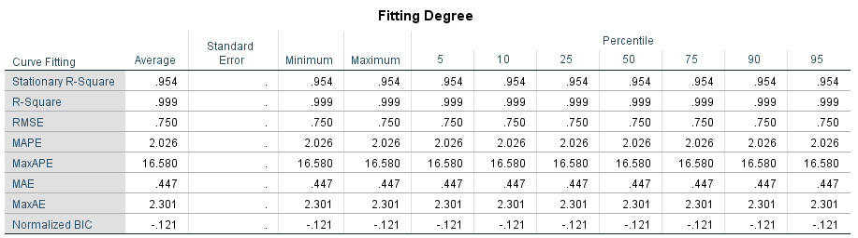

|  |  |  |  |  |  |  |
| --- | --- | --- | --- | --- | --- | --- |
| **Model Statics** | | | | | | |
| Model | Prediction Parameter | Fitness | Yang-Box Q(18) | | | Outlier |
| Stationary R-Square | Statics | DF | Significance |
| ARIMA(1,1,1) | 1 | .954 | 4.334 | 16 | .998 | 0 |